Barracuda Encryption Guide for Clients
Barracuda is an email encryption service. Email encryption is used to protect the content from being read by other entities than the intended recipients.

FWHS is required to encrypt emails if the contents in the email pertain to anything sensitive.
For example, Driver’s License, Social Security number, legal documents, passport, home address etc.
1. To activate: an FWHS staff member will send you an email
2. The email body will look like the below image “Once FWHS sends an email with anything sensitive you will receive an email from noreply@barrauda.com”
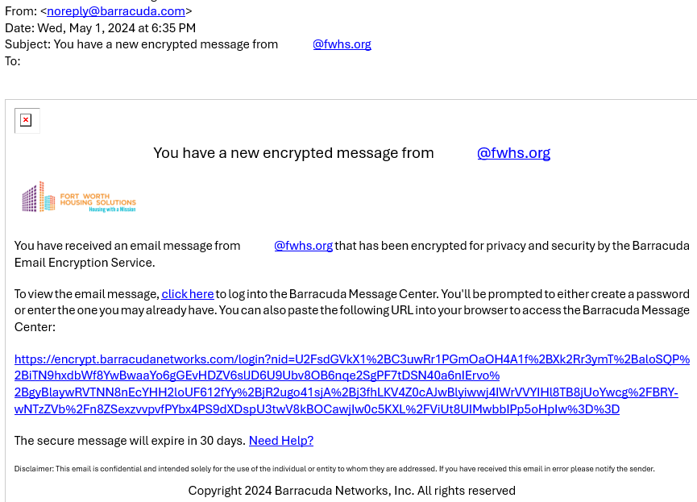

- Select the "click here" (in blue) or copy/paste the URL (also in blue) into your Internet browser to access the Barracuda Message Center.
The first time you log into Barracuda Message Center, you will be asked to set up a password (which must be at least 8 characters in length and include a special character).
Once you have a login setup with Barracuda Message Center, you will see the following screen after you click the link to access the Center.

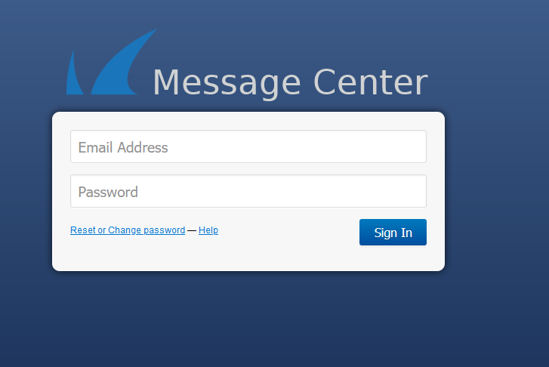
The top box is your email address; the bottom box is the password you created.
- You will see a list of encrypted messages. Click on the message
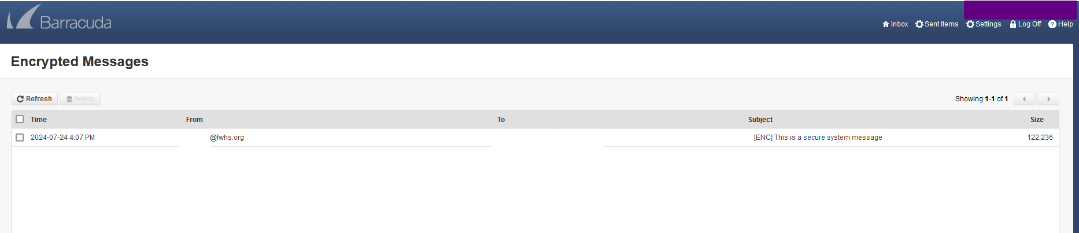
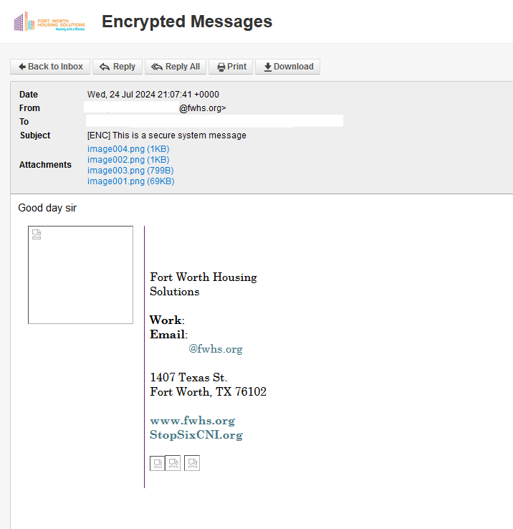
- To respond to the message, you will click “reply”

6. Place your curser at the top of the message and type {enter} a few times to allow you to type a
response at the top of the screen.

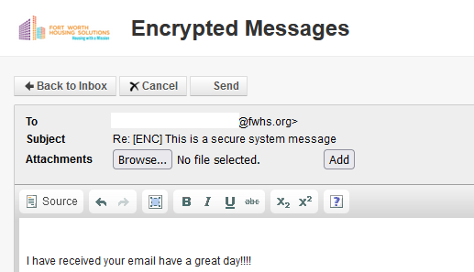
- You may attach a file by clicking on the “browse” button
And select the file from your computer you would like to attach

To send the message, click the “sent” button. 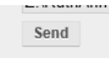

- Click “Back to Inbox” to return to the list of messages. 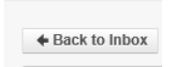

- When you are done, select “Log Off” in the upper right corner of the screen.

